# 

**Shyama Prasad Mukherji Rurban Mission**

**National Rurban Mission**

**(NRuM)**

Integrated Cluster Action Plan

(ICAP)

Cluster:

State :…………….

District:

Sub District:



**Ministry of Rural Development**

**Government of India**

**Checklist for ICAP Preparation**

**Step 1: Selection of Cluster**

Have the sub districts been selected from the Top 20 sub district list?

1. Has the cluster ranking been done as per MoRD methodology
2. What are the no of clusters submitted under Tribal and Non Tribal category
3. How many Gram Panchayats are covered under the cluster?

**Step 2: Delineation & Notification of Planning Area**

1. Has the process of notification of planning areabeen initiated?
2. Has the draft notification of planning area been obtained?

**Step 3- Cluster Profiling**

1. Has the General Profile of the cluster been completed as per the template?
2. Has the socio economic, adminsitrative and socio cultural profiling been done as per template?
3. Has the component profiling also been done as per the suggested tabular analysis?
4. Have additional components also been listed beyond the desirable components?
5. Has a deficiency analysis been done for the cluster?
6. Has a ranking been done amongst the components to identify the components with the largest gaps/needs?

**Step 4- Identification and Detailing of Mission Components-**

1. Has a vision been framed for the cluster based on the identified needs?
2. Has a stakeholder consultation been done to validate the identified components?
3. Has a tentative costing been worked out for development of the cluster?

**Step 5- Scheme Convergence**

1. Have the schemes been identified that could be converged for 70% funding?

**Step 6- Investment and Phasing** 20

1. Has the total investment been phased out over the next 3-5 years?

**Step 7- Arriving at CGF estimate** 20

1. Has the CGF estimate been arrived at taking into account the desirable components and the scheme convergence?

**Step 8- Implementation Strategy** 21

1. Has the Implementation Strategy been worked for execution of the various components?
2. Have the roles and responsibilities been drawn out w.r.t the specific tasks?
3. Have all the stakeholders been consulted while finalizing the strategy?
4. Has an Implementation Strategy been worked out ?

**Step 9- O&M Strategy 22**

1. Has an O&M Strategy been worked for the various components?
2. Have PPP models been worked out for the O&M of various components?
3. Have the roles and responsibilities been drawn out w.r.t the specific tasks?
4. Have all the stakeholders been consulted while finalizing the strategy?

**Step 10- Obtaining Gram Sabha Resolutions 22**

1. Have Gram Sabha resoultions been obtained from all the participating Gram Sabhas?

**Contents**

1.0Setting the context 1

2.0Step by Step Process followed 5

Step 1: Selection of Cluster 5

Step 2: Delineation & Notification of Planning Area 9

Step 3- Cluster Profiling 11

Step 4- Identification and Detailing of Mission Components- Stakeholder

Consultations 18

Step 5- Scheme Convergence 19

Step 6- Investment and Phasing 20

Step 7- Arriving at CGF estimate 20

Step 8- Implementation Strategy 21

Step 9- O&M Strategy 22

Step 10- Obtaining Gram Sabha Resolutions 22

**List of Tables**

Table 1 Ranking Methodology for Non Tribal Clusters 13

Table 2 Selected List of Non Tribal Clusters 12

Table 3: Selected List of Tribal Clusters 14

Table 4: Demographic Profile of the Cluster 16

Table 5: Social Profile of the Cluster 16

Table 6: Economic Profile of the Cluster 17

Table 7: Cultural Profile of the Cluster 17

Table 8: Administrative Profile of the Cluster 17

Table 9: Component Profiling 18

Table 10: Deficiency Analysis and Identification of Needs for a Cluster 20

Table 11: Stakeholder Consultations Summary 23

Table 12: Schemes converged with NRuM 24

Table 13 : Investment Phasing for a Cluster 25

Table 14: CGF estimate for the cluster 25

Table 15: Implementation Strategy for the NRuM components 26

Table 16: Key Construction Milestones 26

Table 17: O&M Strategy for the NRuM components 27

Table 18: Indicative list of Central Sector and Centrally Sponsored Schemes for possible Convergence for the Desirable components within a Rurban Cluster 29

**List of Figures**

Figure 1: Step by Step Process for ICAP preparation………………………...………………….8

Figure 2: Timelines for Infra ICAP Preparation and Submission to MoRD 9

Figure 3:Process of Identification of Non Tribal Rurban Clusters in a State- steps to be

taken by MoRD 11

Figure 5: Process of Identification of Tribal Clusters in a State 14

Figure 6: Map showing delineated Planning Area 15

Figure 6: Steps in Master Planning Exercise 28

**Integrated Cluster Action Plan**

**Cluster:**

**Sub District:**

**District:**

# Setting the context

The National Rurban Mission aims at development of a cluster of villages that preserve and nurture the essence of the rural community life with focus on equity and inclusiveness without compromising with the facilities perceived to be essentially urban in nature, thus creating a cluster of ‘Rurban villages’.

The Mission intends to simulate local economic development, enhance basic services and create well planned Rurban clusters.

Under this Mission, every Rurban cluster will be developed as a project comprising components covering training linked to economic activities, developing skills and local entrepreneurship and will providing necessary infrastructure amenities. These projects will be implemented over a fixed timeframe of three years by integrating and converging the implementation of project components. This will be followed by an operations and maintenance period of ten years.

In order to guide the development of the Rurban cluster, the Mission recommends preparation of an Integrated Cluster Action Plan (ICAP) for each Rurban cluster. The ICAP for a cluster will have two components viz.

1. Socio Economic and Infrastructure Planning Component
2. Initiation of Spatial Planning.

Both the components formsan integral part of the ICAP and has been undertaken in parallel.

The **Socio Economic and Infrastructure Planning component** of the ICAP identifies the socio-economic and infrastructure requirements of the cluster, converge various government schemes and implement the project level interventions in the cluster as per the process indicated in this framework.

The **Spatial Planning Component**: The Spatial Planning component of the ICAP will result in a structure plan/land use plan for the Rurban cluster along with an enforcement mechanism for the same.

The process for preparation of Spatial Plans may be executed over a longer time frame as mandated by the State act.**However, under the ICAP and within the mandated period of 4 months, under the spatial component, it is only intended that States would work towards notifying these clusters as Planning Areas under the relevant State Town and Country Planning Acts and submit the draft notification as part of the ICAP.**

**Spatial Planning Component**

Notification of building and planning regulations and institutionalizing an enforcement mechanism

**Socio Economic and Infrastructure Planning**

Step 1

Selection of Cluster

10

Cluster Profiling

Obtaining Gram Sabha resolutions

Step 14

Step 13

Step 12

Step 11

Step 10

*Note: In the above exercise, the purpose is to initiate the Spatial Planning exercise upto the step of declaration of planning area, within the time frame stipulated for completing the ICAP. (4 months)

Submission of ICAP to MoRD

Scheme Convergence

Revision of ICAP based on approved DPR

Five Yearly Iteration to ICAP

O&M Strategy

Implementation Strategy

Arriving at CGF Estimate

Investment/Phasing

Step 9

Step 8

**Step 7**

Step 6

Step 5

Identification & Detailing of Mission Components

Deficiency Analysis and Identification of needs

Step 4

Step 3

Delineation & Notification of Planning Area*

Step 2

1

Constitution of a Planning Authority/Committee for the Planning Area by the respective Planning Authority

Publication of the Declared Planning Area

Detailed Spatial Map to be drafted

Declaration of Planning Area

Publication of Land Use Map or Land Use Register for Public Review

Consultation on the prepared Land Use Plan

Final Publication & Declaration of the Land Use Map

Preparation of Development Plan

Preparation of Land Use Map and Land Use Register

2

4

5

6

3

Steps 2-7 will be taken up in due course of time

7

Figure : Step by Step Process for ICAP preparation

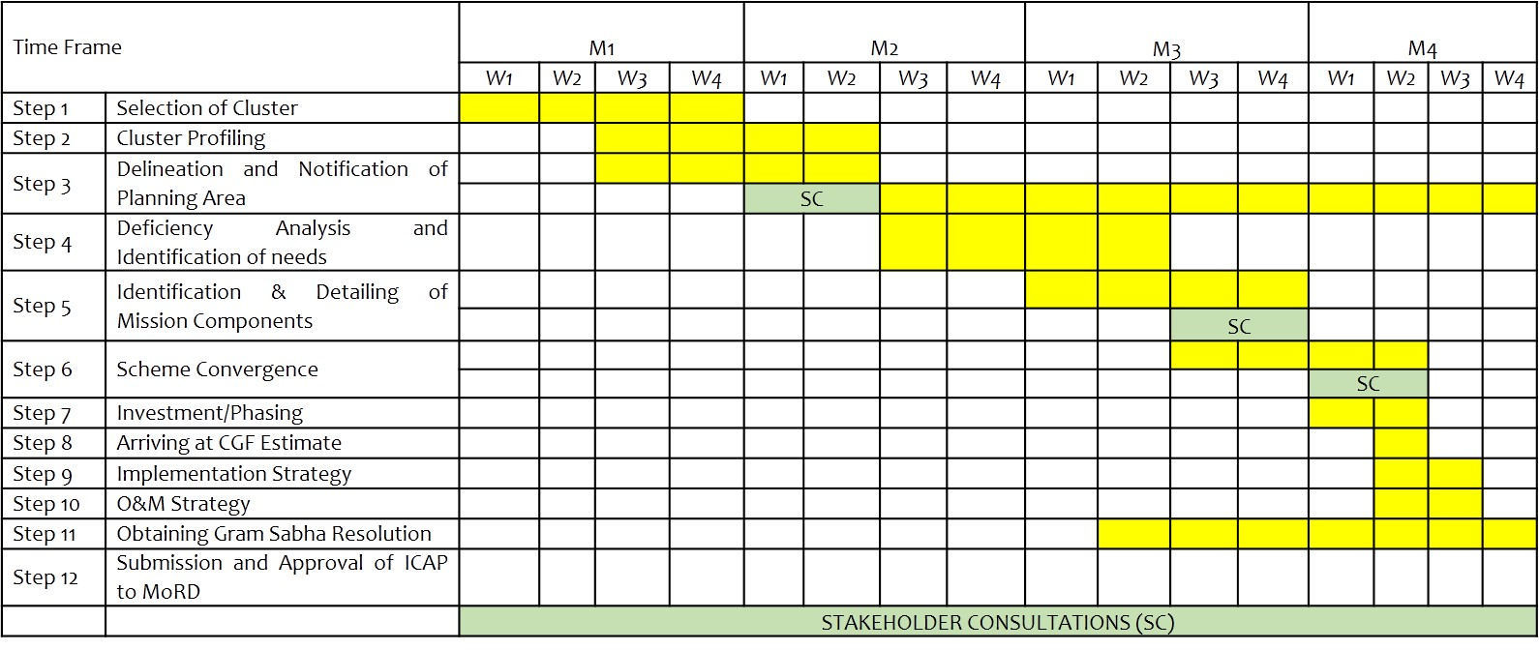

Figure 2: Timelines for Infra ICAP Preparation and Submission to MoRD

# Step by Step Process followed

# Step 1: Selection of Cluster

The cluster selection process followed the process delineated in section 12.0 in the Framework for Implementation. The relevant details about the clusters as defined in the framework of implementation is given below:

* A ‘Rurban cluster’, is defined as a cluster of geographically contiguous villages with a population of about 25000 to 50000 in plain and coastal areas and a population of 5000 to 15000 in desert, hilly or tribal areas. As far as practicable, clusters of village would follow administrative convergence units of Gram Panchayats and shall be within a single block/ tehsil for administrative convenience.
* The cluster selection process was done by the Ministry and the State RD Departments, as per a pre-defined cluster selection methodology. The Ministry identified and shared with the State, a set of potential locations (sub districts) for Rurban clusters and the Stateidentified a set of contiguous villages within the sub district to form a Rurban cluster and prioritized these clusters for funding.
* There are two categories of clusters under SPMRM: Non-Tribal and Tribal and the process of selection varied for each of these categories.
  + 1. **Non- Tribal Clusters:** For selection of Non-Tribal clusters, the Ministry provided a list of leading sub districts to theState, within which the clusters were identified. The selection of these sub districts by the Ministry was done based on parameters such as (i) Decadal Growth in Rural Population (ii)Decadal Growth in Non-Farm work participation (iii) Presence of Economic Clusters (iv)Presence of places of Tourism and Religious significance and (v) Proximity to Transport Corridors. Appropriate weightages were given for each parameter.

Thereafter, within these sub districts, so identified by the Ministry, the State Governments selected the clusters and while doing so, included the following performance parameters:

* + - 1. Decadal growth in Rural Population.
      2. Rise in Land Values.
      3. Decadal growth in Non- Farm Work force participation.
      4. Percentage Enrollment of girls in secondary schools.
      5. Percentage Households with Bank accounts under PradhanMantri Jan DhanYojana.
      6. Performance in Swacch Bharat Mission (Grameen).
      7. Good Governance Initiatives by Gram Panchayats.

(Any other factor, which the States may consider relevant, may also be included).

A weightage of % was given for the first four parameters and % of the last

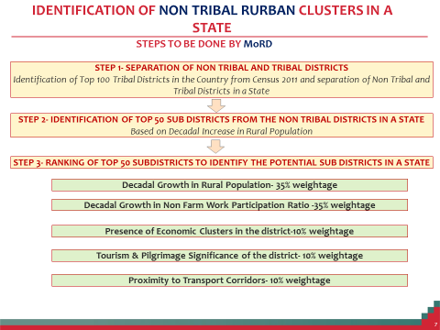

Figure :Process of Identification of Non Tribal Rurban Clusters in State- steps to be taken by MoRD

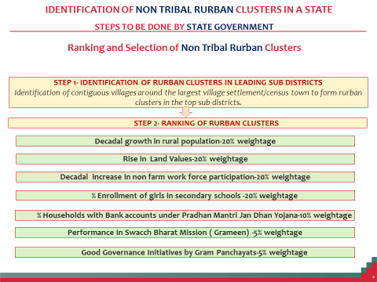

* + - 1. **Ranking of Non Tribal clusters**

Based on the methodology followed above the clusters have been ranked as below

**Pl refer to ranking methodology chart in Table 1 overleaf**

* + - 1. **The Selected Non tribal clusters**

Following the above selection process the State has selected the following Non tribal clusters

Table 2Selected List of Non Tribal Clusters

|  |  |  |  |
| --- | --- | --- | --- |
| **S No** | **District** | **Sub District** | **Cluster** |
|  |  |  |  |
|  |  |  |  |
|  |  |  |  |

* + 1. **Tribal Clusters:** For identification of the tribal clusters, the Ministry has selected the leading sub districts of the State falling within the top 100 tribal districts of the country, based on the Scheduled Tribes population. The selection of these sub districts has been based on parameters such as (i) Decadal growth in Tribal Population (ii) Current Tribal Literacy Rate (iii) Decadal growth in Non- Farm Work force participation (iv) Decadal growth in Rural Population and (v) Presence of Economic Clusters. Appropriate weightages have been suggested respectively for each of these parameters while selecting the sub districts.

Thereafter, within these sub districts so identified by the Ministry, the clusters have been selected and while doing so,the following performance parameters have been selected:

* + - 1. Decadal growth in Tribal Population
      2. Growth in Tribal Literacy rates
      3. Decadal growth in Non- Farm Work force participation.

Table 1 Ranking Methodology for Non Tribal Clusters

|  |  |  |  |  |  |  |  |  |  |  |
| --- | --- | --- | --- | --- | --- | --- | --- | --- | --- | --- |
|  |  | **Criteria – Non tribal** | | | | | | |  | Ranking |
| **Name of Cluster.** | **Name of Sub District** | **Decadal growth in Rural Population** | **Rise in Land Values** | **Decadal growth in Non- Farm Work force participation** | **% Enrollment of girls in secondary schools** | **% Households with Bank accounts under PM Jan Dhan Yojana** | **Performance in Swacch Bharat Mission (Grameen)** | **Good Governance Initiatives by Gram Panchayats** | **Other Parameters** |
|  |  | *Weightage* | | | | | | |  |  |
|  |  |  |  |  |  |  |  |  |  |  |
|  |  |  |  |  |  |  |  |  |  |  |

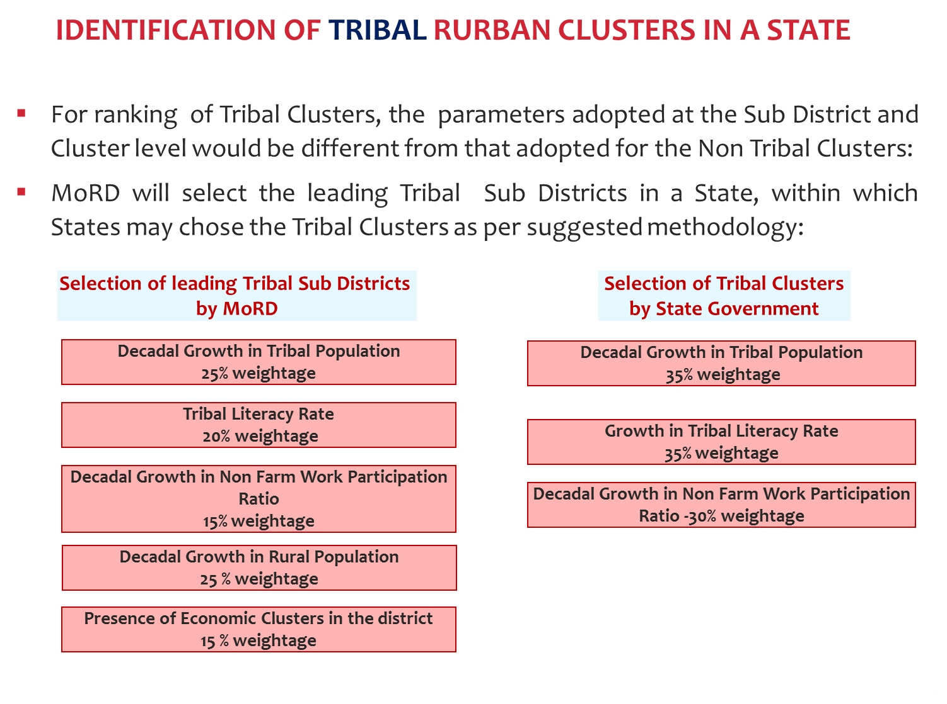

Figure :Process of Identification of Tribal Clusters in a State

* + - 1. **Ranking of Tribal clusters**

Based on the methodology followed above the clusters have been ranked as below:

* + - 1. **The Selected Tribal clusters**

Following the above selection process the State has selected the following Tribal Clusters:

Table 3: Selected List of Tribal Clusters

|  |  |  |  |  |
| --- | --- | --- | --- | --- |
| **S No** | **District** | **Sub District** | **Cluster** | **List of Villages** |
|  |  |  |  |  |
|  |  |  |  |  |
|  |  |  |  |  |

# Step 2: Delineation & Notification of Planning Area

* + 1. ***Delineation of Planning Area:***

The cluster boundary has been clearly delineated following the process specified in theState Town and Country Planning Act.

* + 1. The Planning has been distinctively shown on the map with GIS co-ordinates on a scale of 1:8000.
    2. Planning areas has included full plot nos. (Survey Nos).
    3. ***Notification of Planning Area:*** The planning area so delineated for the clusters has followed the due process of notification:

1. The declaration of the planning area has been widely published in at least 2 local news-papers having wide circulation as well as by a public notice affixed at prominent places, Government offices, local authorities and public places situated within the Planning Area.
   * 1. ***Map showing the planning area delineated***

Figure 6: Map showing delineated Planning Area

# Step 3- Cluster Profiling

The existing profile of the cluster has been detailed out at 2 levels (1) General Profile which includes Demography, Socio Economic, Administrative Profiling (2) Component Profiling

* + 1. ***General Profile:*** Under the General Profiling the Demographic details of the GPs within the cluster, the socio-economic profiling, cultural profiling and the administrative profiling of the GPs have been done. Each of these are elaborated below:
       1. ***Demography:***

The demographic profile of the Gram Panchayats is as detailed below:

Table 4: Demographic Profile of the Cluster

|  |  |  |  |  |  |  |
| --- | --- | --- | --- | --- | --- | --- |
|  | Details | GP -1 | GP-2 | GP-3 | GP-n | Total |
| **Existing** | |  |  |  |  |  |
| 1 | Total Population  (as per census 2011) |  |  |  |  |  |
| 2 | Decadal Growth in Rural Population (%) (2001-2011) |  |  |  |  |  |
| 3 | Household Size |  |  |  |  | (avg.) |
| 4 | Sex Ratio |  |  |  |  |  |
| 5 | Age Profile (Age bracket with the largest % of population) |  |  |  |  |  |
| 6 | Total Land Area |  |  |  |  |  |
|  | Under agriculture |  |  |  |  |  |
|  | Under Forests |  |  |  |  |  |
| **Projected Scenario- 2020** | |  |  |  |  |  |
| 2 | Rural Population |  |  |  |  |  |

**Source:** Census of India / any other GoI or State Government statistical reference

* + - 1. ***Socio Economic& Cultural:***

Table 5: Social Profile of the Cluster

|  |  |  |  |  |  |  |
| --- | --- | --- | --- | --- | --- | --- |
|  | **Details** | **GP -1** | **GP-2** | **GP-3** | **GP-n** | **Total** |
| 1 | Literacy Rate |  |  |  |  |  |
| 2 | SC-Population |  |  |  |  |  |
| 3 | ST- Population |  |  |  |  |  |
| 4 | Education Levels |  |  |  |  |  |
|  | % with Higher Secondary and above |  |  |  |  |  |
|  | % with Senior Secondary and above |  |  |  |  |  |
|  | % with Primary education and above |  |  |  |  |  |
| 5 | % of Population – disabled |  |  |  |  |  |
| 6 | % of Single women |  |  |  |  |  |

Table 6: Economic Profile of the Cluster

|  |  |  |  |  |  |  |
| --- | --- | --- | --- | --- | --- | --- |
|  | **Details** | **GP -1** | **GP-2** | **GP-3** | **GP-n** | **Total** |
| 1 | Occupational Structure |  |  |  |  |  |
| (i) | Farm and Non-Farm work force |  |  |  |  |  |
| (ii) | Women as a % of Work Force |  |  |  |  |  |
| (ii) | Occupation by Industry ( Industry in which majority of the work force is engaged in ) |  |  |  |  |  |
| (iii) | Average distance to work place for majority of the work force in the GP. |  |  |  |  |  |
| (iv) | Anyhome based or traditional industry |  |  |  |  |  |
| 2 | MSME clusters- details |  |  |  |  |  |
| 4 | No f MSME clusters |  |  |  |  |  |
|  | Type of MSME clusters |  |  |  |  |  |

**Source:** SECC/ Census of India or State Government statistical reference/other reliable secondary source

Table 7: Cultural Profile of the Cluster

|  |  |  |  |  |  |  |
| --- | --- | --- | --- | --- | --- | --- |
|  | **Details** | **GP -1** | **GP-2** | **GP-3** | **GP-n** | **Total** |
| 1 | Languages Spoken |  |  |  |  |  |
| 2. | Religion (% of population under each religion) |  |  |  |  |  |
| 3. | Type of Tribes |  |  |  |  |  |
| 4. | Pilgrimage Centres |  |  |  |  |  |
| 5. | Tourist Centres |  |  |  |  |  |
| 6. | Monuments/Places of Heritage |  |  |  |  |  |

**Source:** SECC/ Census of India/ Ministry of Tourism and Culture/ State Government statistical reference/other reliable secondary source

* + - 1. ***Administrative***

Table 8: Administrative Profile of the Cluster

|  |  |  |
| --- | --- | --- |
|  | **Details** |  |
| 1 | No of Gram Panchayats in the cluster |  |
| 2. | Name of the Block Head Quarters |  |
| 3. | Name of the BDO |  |
| 4. | Distance of the Block Headquarters from the largest settlement in the cluster. ( in km) |  |
| 5 | Agencies providing key services   * Water Supply and sanitation * Village streets and drains |  |

* + 1. ***Component Profiling***

Fourteen desirable components have been listed out as ideal components for the cluster, however giving flexibility to the States to decide any other relevant components required to develop the cluster.The following components are envisaged as desirable components in each cluster: (i) Skill development training linked to economic activities (ii) Agro Processing, Agri Services, Storage and Warehousing.(iii) Fully equipped mobile health unit.(iv) Upgrading school /higher education facilities. (v) Sanitation (vi) Provision of piped water supply. (vii) Solid and liquid waste management. (viii) Village streets and drains. (ix) Street lights (x) Inter-village road connectivity. (xi) Public transport. (xii) LPG gas connections (xiii) Digital Literacy.(xiv) Citizen Service Centres- for electronic delivery of citizen centric services/e-gram connectivity

In order to arrive at the most desirable components amongst the 14 listed components, it is important to understand the existing/current situation in the cluster w.r.t each of the components. The profiling has been done as per the template givenbelow:

Table 9: Component Profiling

|  |  |  |
| --- | --- | --- |
|  | **Desirable Component** | **Existing Situation** |
| 1 | Skill Development training Linked to Economic Activities | -Existing skills in the GP  (Handicraft/Handloom/Industrial etc.)  - Skilled members at the household level |
| 2 | Agri-services and Processing | Detail the existing Agri services and processing industries present in the cluster. |
| 3 | Digital Literacy | Detail the existing levels in terms of core IT infrastructure as well as general digital literacy levels at the HH and Village level. |
| 4 | 24x7 Piped Water Supply | Existing levels of water supply at the household level. |
| 5 | Sanitation | Coverage of Individual Toilets in the GP at the household level |
| 6 | Solid and Liquid Waste Management | Existing arrangement for solid and liquid waste management at the Household/Village and Cluster level. |
| 7 | Access to Village Streets with Drains | - Existing coverage of village streets and drains. |
| 8 | Village Street Lights | Coverage of existing GP streets with street lights |
| 9 | Health | -Access to clinics and health centers at the household and village level. |
| 10 | Up gradation of primary, secondary and higher secondary schools. | - Existing nos. of primary, secondary and higher secondary schools in the cluster and existing conditions. |
| 11 | Inter village roads connectivity | - Connectivity between GPs within the cluster with roads and public transport |
| 12 | Citizen Service Centres | - Existingnos. of citizen service centers at the GP level |
| 13 | Public transport | - Existing levels of availability w.r.t Public Transport facilities both intra and inter GP |
| 14 | LPG Gas Connections | Access to LPG connections at the household level (No of household with LPG connections) |
| 15 |  |  |
| 16 |  |  |
| 17 |  |  |

**Source:** Respective Scheme Data Base/GP records/census of India/other reliable source

Table 10: Deficiency Analysis and Identification of Needs for a Cluster

|  | *A* | B | C | D= C-B |
| --- | --- | --- | --- | --- |
|  | *Desirable Component* | Existing Situation | Desired Levels | Gaps/Need |
| 1 | Skill Development training Linked to Economic Activities | -Existing skills in the villages .  ( Handicraft/Handloom/Industrial etc)  No of skilled members at the HH level | At-least 70 percent household with one beneficiary in each household. | Identification of training needs in terms of sector and no of people to be trained with age profiling. |
| 2 | Agri-services and Processing | - Detail the existing Agri services and processing industries present in the cluster.(Including storage infrastructure) |  | Identification of support to any agri based service/industry/storage infrastructure. |
| 3 | Digital Literacy | - Detail the existing levels in terms of core IT infrastructure as well as general digital literacy levels at the HH and Village level. | At least one e-literate person in every household. | Identification of no of people to be digitally literate in the cluster. |
| 4 | 24x7 Piped Water Supply | - Existing levels of water supply at the household level. | 70 liters per capita per day (lpcd) of safe drinking water for every households throughout the year | Identification of Augmentation needs at the household level and type of augmentation- source/transmission/distribution |
| 5 | Sanitation | - Coverage of Individual Toilets in the villages at the household level | 100% HH with Individual Household Latrines | Identification of no of households to be covered with individual latrines. |
| 6 | Solid and Liquid Waste Management | - Existing arrangement for solid and liquid waste management at the Household/Village and Cluster level. | Collection at HH level  Treatment at Cluster Level | Identification of SWM facilities at collection/transportation/treatment. |
| 7 | Access to Village Streets with Drains | - Existing coverage of village streets and drains. | All village streets to be covered with drains | Identification of length of streets yet to be covered with drains. |
| 8 | Village Street Lights | - Coverage of village streets with lights | All village streets to be covered with street lights as per norms | Identification of no of street lights to be provided. |
| 9 | Health | Access to clinics and health centres at the household and village level. | Access to Health infrastructure as per norms | Identification of need for Mobile Health Units. |
| 10 | Up gradation of primary, secondary and higher secondary schools | - Existing nos. of primary, secondary and higher secondary schools in the cluster and existing conditions. | Ensuring primary and secondary school within a reasonable distance from all households along with facilities of Drinking water provisions, Toilet blocks (separate for boys and girls) and adequate classrooms. | Identification of up gradation needs/new facilities in the primary and secondary schools |
| 11 | Inter village roads connectivity | Connectivity between villages within the cluster with roads and public transport | Ensure connectivity between all villages. | Identification of need for new connectivity between villages. |
| 12 | Citizen Service Centres | Existingnos of citizen service centres at the village level | One ICT enabled front end Common Service Centre (CSC) per 2 to 3 villages | Identification of no of CSCs required for the cluster. |
| 13 | Public transport | Existing levels of availability w.r.t Public Transport facilities both intra and inter village. | Public transport to block from each village | Need for additional facilities to improve public transport access to each village. |
| 14 | LPG Gas Connections | Access to LPG connections at the household level | One LPG retail outlet per village or per 1800 households | Need for additional retail outlets in the cluster. |
| 15 |  |  |  |  |
| 16 |  |  |  |  |
| 17 |  |  |  |  |

# Step 4- Identification and Detailing of Mission Components- Stakeholder Consultations

1. ***Vision for the cluster***
2. ***Stakeholder Consultation(Minutes of the meetings)***
3. Summary of Stakeholder consultations

Table 11: Stakeholder Consultations Summary

|  |  |  |  |
| --- | --- | --- | --- |
|  | ***Date*** | ***List of Participants*** | ***Key findings*** |
|  |  |  |  |
|  |  |  |  |
|  |  |  |  |

1. ***Identified components for funding***
2. ***Tentative Costing for (c) above***

# Step 5- Scheme Convergence

The following schemes have been identified for successful convergence with NRuM:

Table 12: Schemes converged with NRuM

|  |  |  |  |
| --- | --- | --- | --- |
| Component | Scheme Converged | Whether Central Sector/Centrally Sponsored/State Government Scheme | Brief Overview of Scheme |
|  |  |  | -Components funded  -% of funding  -Targets for next 5 years |
|  |  |  |  |

# Step 6- Investment and Phasing

The Investment required and the phasing of the investments is as given below:

Table 13 : Investment Phasing for a Cluster

|  |  |  |  |  |  |
| --- | --- | --- | --- | --- | --- |
|  |  |  | Investment phasing over the construction period | | |
| ***Project component*** | ***Name of the Scheme converged*** | ***Investment Required* [A]**  ***( Rs in lakhs)*** | **Year 1** | **Year 2** | **Year 3** |
| 1 |  |  |  |  |  |
| 2 |  |  |  |  |  |

# Step 7- Arriving at CGF estimate

As per the Mission framework the CGF will be restricted to 30% of the Project capital expenditure or Rs. 30 crores,whichever is less in plain areas. In desert, hilly and tribal areas the CGF will be capped at 30% of the Project capital expenditure or Rs. 15 crores- whichever is less. The total investment required as estimated in Step 7 above, the resources that can be obtained through convergence and the balance CGF amount, capped as per the norms, have been detailed out as given below:

Table 14: CGF estimate for the cluster

|  |  |  |  |  |  |  |  |  |
| --- | --- | --- | --- | --- | --- | --- | --- | --- |
| *Project component* | *Name of the Scheme converged* | *Investment Required (Rs in lakhs)*  [A] | Funding available through the scheme (Rs Lakhs) | | | | Funding gap  [C=A-B] | Project sub component identified for gap funding |
| ***GoI*** | ***State***  ***Govt*** | ***Beneficiary share, if any*** | ***Total funding available [B]*** |
| 1 |  |  |  |  |  |  |  |  |
| 2 |  |  |  |  |  |  |  |  |
| 3 |  |  |  |  |  |  |  |  |
| **Total** |  | ***Total investment required*** | Total GoI | Total State share | Total beneficiary share | **Total funding available** | **Total Gap** |  |

# Step 8- Implementation Strategy

The next step is to identify the implementation modalities for the Mission which couldbroadly include the following:

***Capital Works***

1. Implementation of all components of the project by the State Government agencies.
2. Implementation through PPP.

The implementation framework till the commencement of construction activities at site is as under.

Table 15: Implementation Strategy for the NRuM components

|  |  |  |  |  |  |  |  |
| --- | --- | --- | --- | --- | --- | --- | --- |
| Project component | Implementing agency/ officer responsible for execution | Key Implementation Milestone dates | | | | | |
| **DPR preparation** | **Approval of DPR** | **Preparation of Tender Documents** | **Notice inviting bids** | **Appointment of contractor** | **Construction start** |
|  |  |  |  |  |  |  |  |
|  |  |  |  |  |  |  |  |
|  |  |  |  |  |  |  |  |

The key milestones for monitoring construction at the cluster, will be as under;

Table 16: Key Construction Milestones

|  |  |  |  |  |  |  |
| --- | --- | --- | --- | --- | --- | --- |
| Project component | Implementing agency/ officer responsible for execution/ name of the contractor | Key Construction Milestone dates | | | | |
| **Construction start** | **Completion of 30% activities at site** | **Completion of 60% activities at site** | **Submission of UCs** | **Commissioning of the project component** |
|  |  |  |  |  |  |  |
|  |  |  |  |  |  |  |
|  |  |  |  |  |  |  |

Effective project coordination and monitoring can be done by the District Project Management Unit (DPMU) and the Cluster Development and Management Unit (CDMU). The above charts will be dynamic documents and will be constantly updated based on the progress of the implementation of the project components at the cluster by the CDMU during the implementation phase.

# Step 9- O&M Strategy

The O&M Strategy for the Mission would be as under:

* O&M of the project components by the Gram Panchayats, State Government agencies or private partners.
* O&M of project components like water supply, sewerage, solid waste management etc. as a combined utilities management contract with a private sector operator.

The Operations and Maintenance Expenses of the project will be recovered through user charges as per the user charges policy in the State with shortfall supported by the State budget.

A summary Statement on the O&M strategy is as under;

Table 17: O&M Strategy for the NRuM components

|  |  |  |  |  |  |  |  |
| --- | --- | --- | --- | --- | --- | --- | --- |
| *Project component* | *O&M agency* | *Annual O&M expenditure* | *Sources of O&M funds* | | | *Shortfall in recovery of O&M expenses* | *Remarks on O&M strategy* |
| ***User charges*** | ***14th Finance commission/ grants*** | ***Total sources*** |
|  |  |  |  |  |  |  |  |
|  |  |  |  |  |  |  |  |

# Step 10- Obtaining Gram Sabha Resolutions

Stakeholder consultations have been held at all levels and the details are annexed in . Once the stakeholders arrive at a consensus on the Infra ICAP.

The Gram Sabha resolutions have been obtained and annexed.

Figure 7: Steps in Master Planning Exercise

1

Constitution of a Planning Authority/Committee for the Planning Area by the respective Planning Authority

Publication of the Declared Planning Area

Detailed Spatial Map to be drafted

Declaration of Planning Area

Publication of Land Use Map or Land Use Register for Public Review

Consultation on the prepared Land Use Plan

Final Publication & Declaration of the Land Use Map

Preparation of Development Plan

Preparation of Land Use Map and Land Use Register

2

4

5

6

Notification of building and planning regulations and institutionalizing an enforcement mechanism

7

In addition to Spatial Planning this component of the ICAP shall also notify planning and institutionalize enforcement mechanisms for the Rurban cluster.

The Ministry will support Spatial Planning component of the ICAP by preparing Model Planning and Landuse regulations and enforcement mechanisms. The State Planning Authority may appropriately modify the same to suit the States context.

***************

Table 18: Indicative list of Central Sector and Centrally Sponsored Schemes for possible Convergence for the Desirable components within a Rurban Cluster

| S. No. | Desirable components | Desirable Outcome | Potential Scheme for convergence | |
| --- | --- | --- | --- | --- |
|  |  |  | Name | Brief |
| 1 | Skill Development training Linked to Economic Activities | At-least 70 percent household with one beneficiaries in each households. | DeenDayalUpadhyayaGrameenKaushalyaYojana (DDU-GKY) | DeendayalUpadhayaGraminKaushalyaYojana is scheme implemented by Ministry of Rural Development.  The key features of the scheme are: 1) Outcome led design 2) Guaranteed Placement for at least 75% trained candidates 3) Shift in emphasis from training to career progression 4) Post placement support, migration support and alumni network to enable farm to factory transition. 5) Industrial Internships 6) Skill training programs that are based on national and international market demand 7)Special Regional focus - Sub-schemes for J&K (Himayat) and for 27 most affected Left Wing Extremist (LWE) districts (Roshini) across nine States |
| 2 | (i) Agri-services and Processing | Support to the Agriculture and Allied Activity components as per RKVY | RashtriyaKrishiVikasYojna (RKVY) | RashtriyaKrishiVikasYojna (RKVY) by the Department of Agriculture, Cooperation and Farmer Welfare under the Ministry of Agriculture and Farmer Welfare intends to incentivize the States so as to increase public investment in Agriculture and allied sectors. The scheme gives autonomy to the States to draw up plans for executing Agriculture and allied sector schemes taking into consideration the agro-climatic conditions, availability of technology, natural resources and cropping patterns in the respective districts. The components for which the scheme provides support includes Crop Husbandry (including Horticulture), Animal Husbandry and Fisheries, Dairy Development, Agricultural Research and Education, Forestry and Wildlife, Plantation and Agriculture Marketing, Food Storage and Warehousing, Soil and Water Conservation, Agricultural Financial Institutions, other Agricultural Programs and Cooperation and expenditures directly related to the development of agriculture viz., expenditure on shallow tube well, deep tube well, drip irrigation, sprinkler irrigation, dug wells or other similar irrigation activities which are budgeted under the Agriculture Department of the State |
|  | (ii) Agri services and farm productivity | Support to components under end to end irrigation supply chain as per PMKSY | PradhanMantriKrishiSinchaiYojna (PMKSY) | PradhanMantriKrishiSinchaiYojna (PMKSY) by the Department of Agriculture and Cooperation and Farmer Welfare under the Ministry of Agriculture and Farmer Welfare intends to ensure access to protective irrigation to all agricultural farms in the country to produce ‘per drop more crop’, thus bringing much desired rural prosperity. PMKSY will be focusing on end-to end solution in irrigation supply chain, viz. water sources, distribution network, efficient farm level applications, extension services on new technologies & information etc. |
|  | (iii) Agri Services | Support to organic farming cluster identified under PKVY | ParamparagatKrishiVikas Yojana (PKVY) | ParamparagatKrishiVikas Yojana (PKVY) support and promote organic farming thereby improving soil health. Under PKVY Organic farming is promoted through adoption of organic village by cluster approach and Participatory Guarantee System (PGS) certification. In three years 10,000 cluster covering 5.0 lakh acre organic farming areas is to be developed under PKVY by providing Rs. 20,000/- per acre per farmer for seeds and transport facilities. |
| 3 | Digital Literacy (access to digital resources for all citizens) | At least one e-literate person in every household. | Digital India | Ensuring Universal digital literacy is one of the component under Digital India mission, which intend to provide the citizens the ability to fully exploit the digital technologies to empower themselves. It helps them seek better livelihood opportunities and become economically secure. The programme focuses on digital literacy by ensuring at least one e-literate person in every household by using core ICT infrastructure set up by the central and State governments, such as CSCs, National Optical Fiber Network (NOFN) and 5000 facilitation centers to be set-up by National Institute of Electronics and Information Technology (NIELIT) and by providing 100 Mbps links to 2,50,000 gram panchayats through optical fiber cable as per Digital India Norms. |
| 4 | 24x7 Piped Water Supply | 70 liters per capita per day (lpcd) of safe drinking water for every households throughout the year | National Rural Drinking Water Programme (NRDWP) | National Rural Drinking Water Program is implemented by MoDWS and the scheme intended to provide Provision of Piped water supply to households, ensuring sustainability in drinking water schemes and convergence of all water conservation programmes. By 2022, the scheme aims to provide every rural person in the country with access to 70 lpcd water within their household premises or at a horizontal or vertical distance of not more than 50 meters from their household without barriers of social or financial discrimination. Individual States can adopt higher quantity norms, such as 100 lpcd. |
| 5 | Sanitation | 100% HH with Individual Household Latrines | Swachh Bharat Mission-Gramin | The SBM(G) is implemented by MoDWS with aims to 1) Accelerate the efforts to achieve universal sanitation coverage and focus on sanitation, 2) The mission strives to improve the levels of cleanliness in rural areas through Solid and Liquid Waste Management activities 3) Making Gram Panchayats Open Defecation Free (ODF), clean and sanitized. |
| 6 | Solid and Liquid Waste Management | Solid waste collection + Secondary transport for all HHs wastes and liquid waste management |
| 7 | Solid Waste Treatment / Vermi compost Pit | 1 vermi-composting plant per 2500 persons/ liquid waste unit (as per SBM-G guideline) |
| 8 | Village Streets with Drains | All village to be covered with Drains | Applicable Central and State government schemes | The design under this sub component should aim at providing all weather paved streets within the villages with adequate drains for storm water disposal. The storm water disposal system should be separate from the sewerage network. |
| 9 | Street Lights | All village to be covered with Street Lights | Applicable Central and State government schemes | The design under this sub component should aim at providing streets within the villages with adequate street lights and safe alignment design. Preferably, solar Street lights shall be provided and at intervals prescribed under relevant standards. |
| 10 | Fully equipped Mobile Health Unit | Mobile Unit as per NHM norms | National Rural Health Mission (NHM) - Rural | National Rural Health Mission implemented by Ministry of Health and Family Welfare has provision of Mobile Medical Unit (MMUs) to provide outreach services in rural and remote areas. This is not meant to transfer patients. MMUs comprise of one/two or three vehicles varying State-wise. Where there is more than one vehicle then 1)One vehicle is used for transport of medical and Para-medical personnel, 2) Second is used for carrying equipment/ accessories and basic laboratory facilities, 3) Third vehicle carries diagnostic equipments such as X-Ray, ultrasound, ECG machine and generator. Each unit has- one doctor, one nurse, one radiologist, one lab attendant, one pharmacist and a helper and driver. There is provision of medicines in the unit. |
| 11 | Up gradation of primary, secondary and higher secondary schools | Ensuring primary and secondary school within a reasonable distance from all households along with facilities of Drinking water provisions, Toilet blocks (separate for boys and girls) and adequate class rooms. | RashtriyaMadhyamikShikshaAbhiyan (RMSA).  SarvaShikshaAbhiyan (SSA) RashtiryaUchchatarShikshaAbhiyan and | RashtriyaMadhyamikShikshaAbhiyan (RMSA) and SarvaShikshaAbhiyan (SSA) are schemes run by the Ministry of Human Resource Development. The objective of RMSA is to improve quality of education imparted at secondary level through making all secondary schools conform to prescribed norms and Universal access to secondary level education by 2017.  RashtiryaUchchatarShikshaAbhiyan is another umbrella scheme to be implemented in mission mode that would subsume other existing schemes in the sector. Funding by the programme to States is spread across 18 components including upgradation of existing autonomous colleges and conversion of colleges in a cluster. |
| 12 | (i) Inter village roads connectivity | Ensure connectivity between all villages | PradhanMantri Gram SadakYojana (PMGSY) for road connectivity | PradhanMantri Gram SadakYojana implemented by MoRD. The PMGSY aims to provide 1) all-weather road connectivity to unconnected rural habitations 2) Accessibility of unconnected habitations to the services (educational, health, marketing facilities etc.), which are not available in the unconnected Habitation. |
|  | (ii) Public transport. | Public transport to nearest urban center from each block | Applicable State government schemes | The design of this component shall aim at providing public transport connectivity to nearest urban center from each block, villages with economic importance and the villages within the cluster. The provision of public transport should be through State Transport Agencies or through licensing of routes to private operators for provision of buses or intermediate modes of public transport. |
| 13 | Citizen Service Centres- for electronic delivery of citizen centric services/e-gram connectivity | One ICT enabled front end Common Service Centre (CSC) per 2 to 3 villages | Digital India Mission | Under Digital India mission, Easy access to a Common Service Centre (CSC) component is implemented under the NeGP formulated by DeitY, the CSCs are ICT-enabled front-end service delivery points (kiosks) at the village level for delivery of government, financial, social and private sector services in the areas of agriculture, health, education, entertainment, banking, insurance, pension, utility payments, etc. CSCs operate within a public-private-partnership (PPP) model and a 3-tier structure consisting of the CSC operator (known as the Village Level Entrepreneur or VLE). Under the proposed CSC 2.0, it is planned to increase the number of CSCs to 2,50,000 (covering all panchayats) to facilitate easier access to CSCs for the citizens. |
| 14 | LPG Gas Connections/Improved Chulhas | One LPG retail outlet per village or per 1800 households | Rajiv Gandhi Gramin LPG Vitaran (RGGLV) | Rajiv Gandhi GraminVitaranYojana (RGGLV) provides one time financial assistance to the BPL Category for new LPG connection. Under this scheme, cost of Security Deposit and Pressure Regulator (at present 1450+150=1600) is met from the funds of the public sector Oil Marketing Companies (OMCs) created for this purpose by the contributions from the Corporate Social Responsibility (CSR) fund of six major oil companies e.g. ONGC, OIL, GAIL, BPCL, HPCL and IOCL. Locations for setting up of Rajiv Gandhi Gramin LPG Vitrak (RGGLV) are identified broadly based on potential of average monthly sale of 600 LPG cylinders of 14.2 kg and 1800 customers with monthly per capita consumption of about 5 Kg. |

**Source**: Respective Ministry web sites